Benjamin Franklin Elementary
Kindergarten Supply List
- 1 pack of Pencils  #2 lead, yellow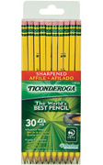 | - Headphones  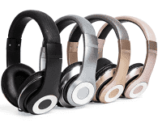 | - 1 pack of Glue sticks  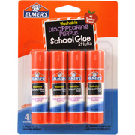
- 1 box of markers  - 1 box of 24 crayons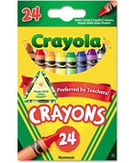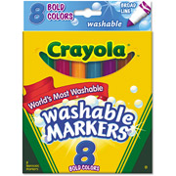 | - 1 sandwich size  - 1 quart size  - 1 gallon size  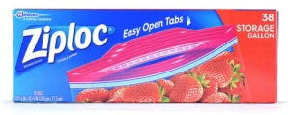 | - 1 pack of index cards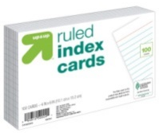
- 3 writing journals | - 2 containers of Clorox wipes 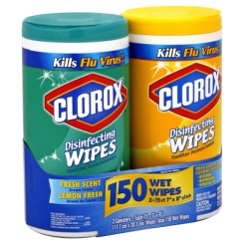 | - 1 rolls of paper towels 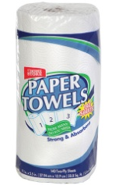
- 1 pencil pouch (no boxes)  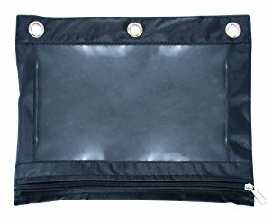 | - 2 boxes of Facial tissues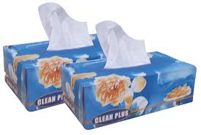 | - 5 Black dry erase markers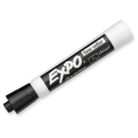
- 1 Hand Sanitizers with pump  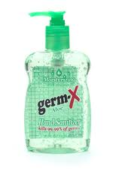 | - 4 Reams of  Copy Paper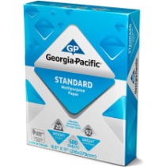 | - 2 packs of baby wipes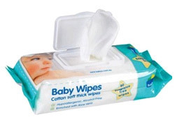

Please bring all supplies to school on the first day with your child. Thank You!
**PLEASE NOTE all supplies will stay in school. You may want to keep an extra set of pencils and crayons at home for homework. **

